**Measuring Regression Performance**

**Evaluation Metrics for performance (RSS, R-Squared, RMSE, MAE etc)**

How well a regression model performs can be obtained by how close the predicted value is to the ground truth. It is very important to use the appropriate metric to evaluate the performance. In this section, we discuss some examples of metrics used in evaluating regression models such as RSS, R-Squared, RMSE and MAE

**Mean Absolute Error (MAE)**

MAE  is easy and intuitive such that it calculates the sum of the  average of the absolute error between the predicted values and the true values. Since the absolute difference is taken, this metric does not consider direction. However, because the absolute difference is obtained, it is unable to give information about the model overshooting or undershooting. The smaller the MAE is, the better the model. Therefore, if the MAE is 0, the model is perfect and accurately predicts results which is almost impossible.  The mean absolute error is more robust to outliers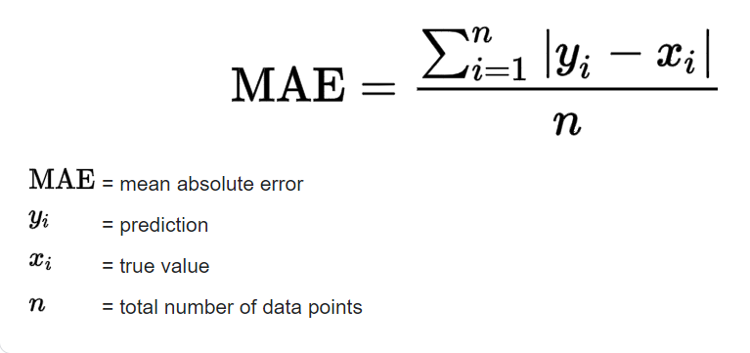

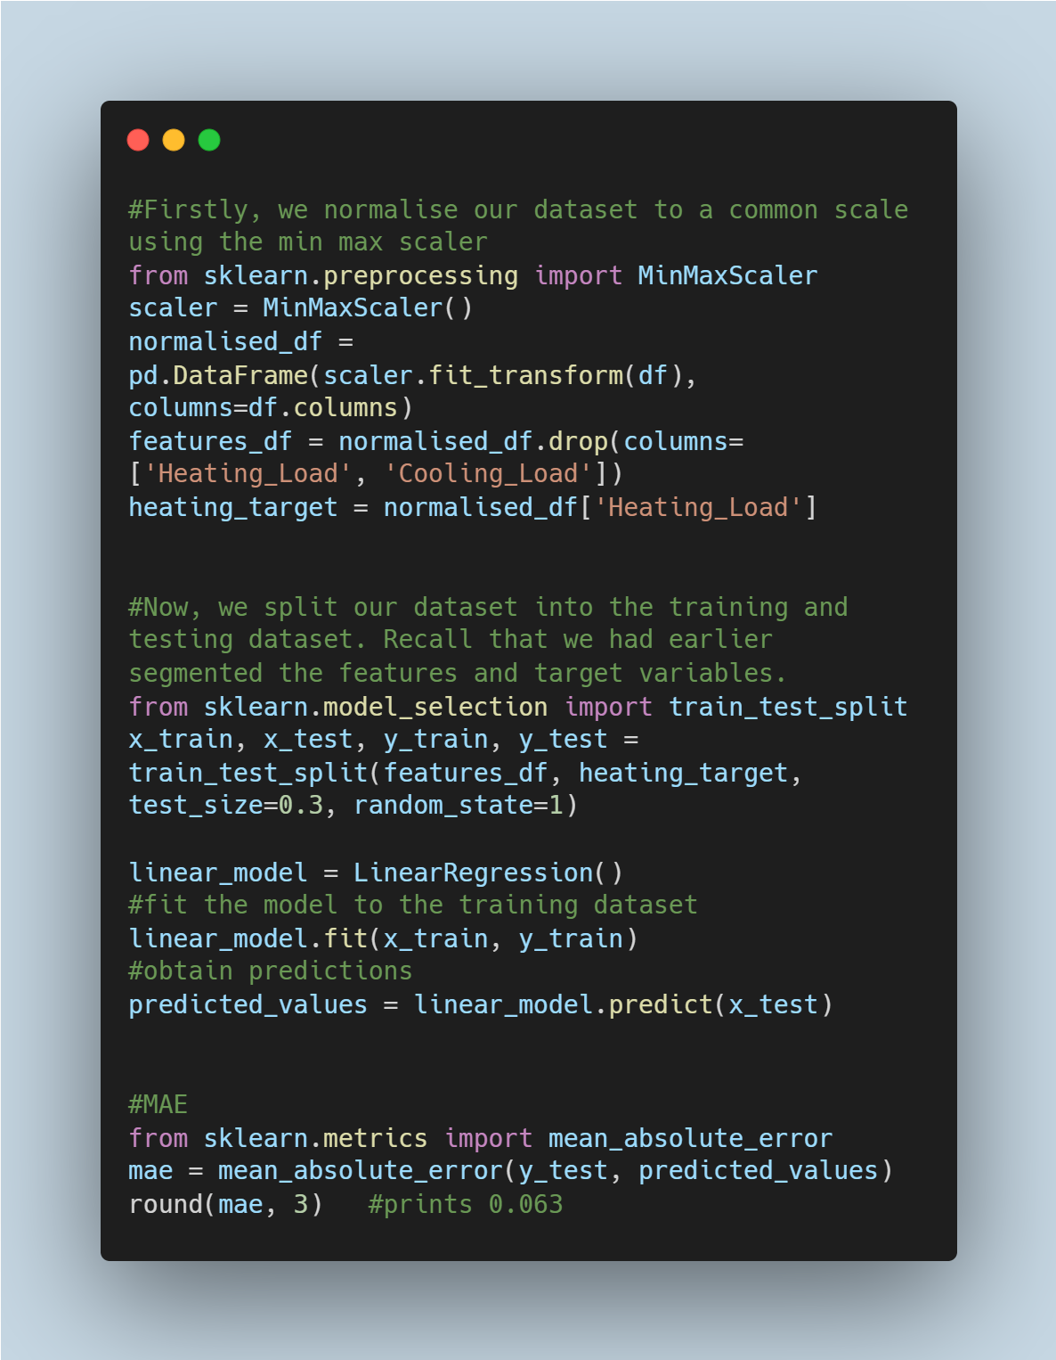

**Residual Sum of Squares (RSS)**

Also known as the sum of squared residuals (SSR), this metric explains the variance in the representation of the dataset by the model; it measures how well the model approximates the data. A residual is the estimated error made by a model. In simpler terms, it is the difference between the nth true value and the nth predicted value by the model. RSS is the sum of the square of errors between the residuals in a model. The lower the RSS, the better the model’s estimations and vice versa.

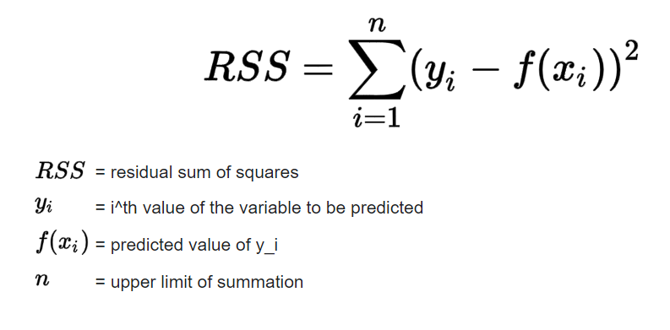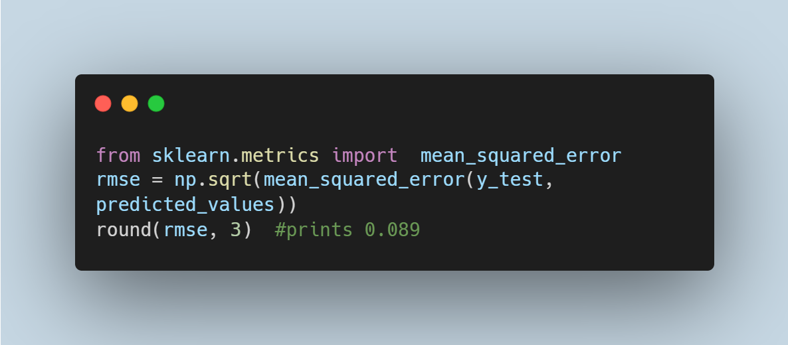

**R-Squared**

Also known as the coefficient of determination, r-squared is a metric used in regression to determine the goodness of fit of the model. With values ranging from 0 to 1, It gives information on the percentage of the response variable  explained by the model. Mostly, the higher the value, the better the model however, 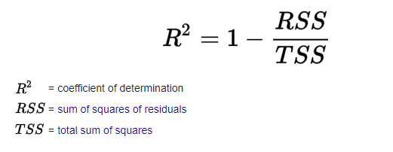

this is not necessarily always true.

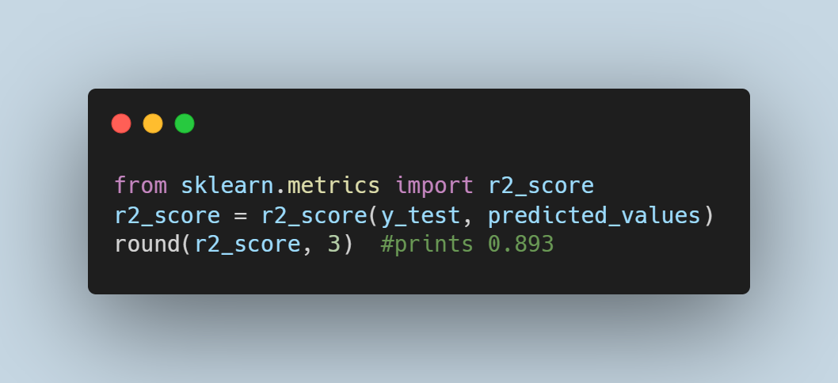

**Model complexity, Underfitting and Overfitting**

Model complexity refers to the number of input features used to train a model and the algorithmic learning complexity. An overly complex model can be difficult to interpret, prone to overfitting and also require more computing. When creating models, it is imperative for the model to generalise well enough to make reasonable predictions on new and unseen data. An overfit model will perform well on the training data and poorly on unseen data. While a model is required to learn the actual relationship of the variables in the training set, an overfit model memorises the training set, fits the noise, outliers and irrelevant information, then makes predictions based on this noise which is incorrect. On the other hand, when a model is too simple, it can be as a result of having very few features not sufficient enough to learn details and relationships in the data.  In a later section, we will discuss methods that can be used to achieve optimal and acceptable model complexities while avoiding overfitting and underfitting.

**The Bias-Variance tradeoff**

Bias and variance are common occurrences in machine learning and there is a constant struggle to achieve low bias and variance. Bias is a measure of correctness of a model i.e. how far off is a model from being correct? While high bias results in an increase in the error by making assumptions which prevent the model from capturing relevant relationships between the predictors and response variable, low bias gives lower error and also prevents underfitting by capturing important relationships. On the other hand, variance tells how much the values estimated by a model will vary across different training data. When the variance is low, it means that there is only a small change in the estimate of the model with  new training  data. A high variance causes overfitting such that the changes in estimates obtained with new training data is large because the model is so complex that it has now learnt patterns from one training data such that it cannot generalise to other training sets. While it is essential to obtain low bias and low variance, it is almost impossible to achieve this simultaneously which is where the ‘bias-variance tradeoff’ occurs.

